**Before explaining to you the z table and z score.**

**We take on real-world example,i.e…**



**in the real world if we want to communicate with each other we require English as language. Like the same way for calculating or comparing different types of data, we require standardization or normalization. Let’s understand about standardization.**

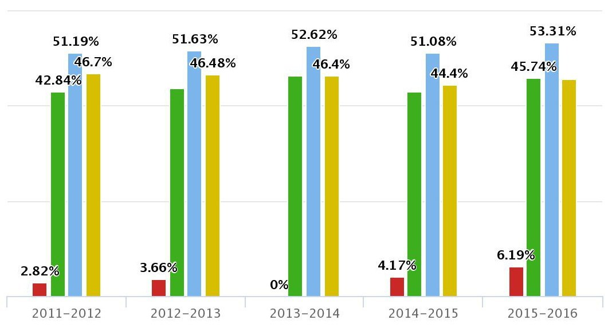

**In the above barplot, we have four kinds of data.**

**z**-**score** is the number of standard deviations from the mean a data point is. A **z**-**score** is also known as a standard **score**

Where we can only compare x variable with Z values (or) Z score, if the x variable is a normal distribute data, with the help of the Q-Q plot, we can know the variable is normally distributed or not.

Z values (or) Z score are standardized values,

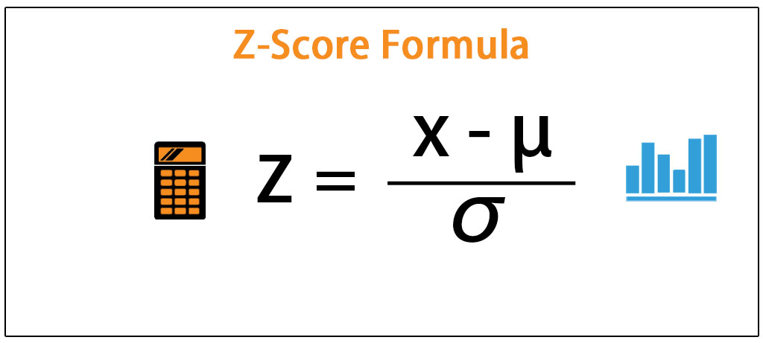

Z values (or) Z score is the number of standard deviations is from the mean.

-> The use of Z values (or) Z score is used to make the continuous Normal data into standardize normal data .why we want to do the standardize value because some variables will have a different scale, ex:-SAT score(1600) and ACT (36) score .both are different scales. With the help of Z score, we can convert all different scale variables into a standardizing form and then we can compare one variable to another variable. In the z table, we will see the z score probability value. the z table is consists of probability for each z score.

here we cannot see the single point probability, because the single value of the probability is zero.so we will sum up the initial point to the x point.

**Here we are assuming the x value as a z value in the standardization graph and finding the probability with the help of z table.**

standard normal table

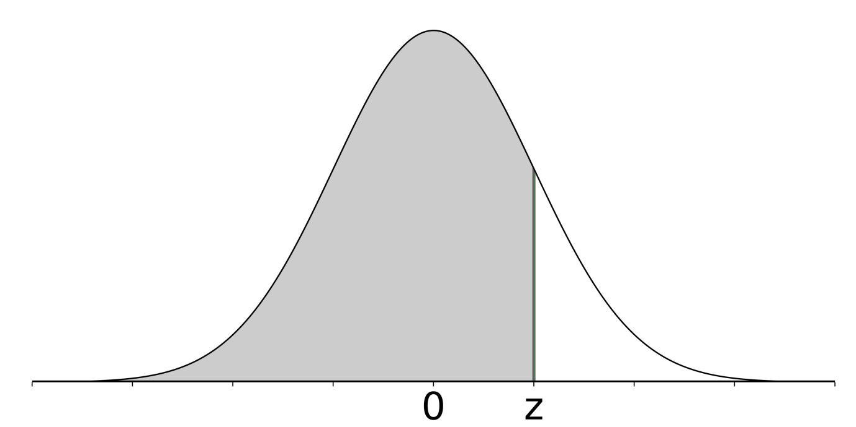

**Here we are assuming the x value as a z value and finding the probability with the help of z table.**

standard normal table

Adarsh scored a 27 on his ACT.javeed scored 1120 on his SAT.which of the two test-takers scored better on their respective tests? What proportion of people scored worse than Adarsh and Javeed? Assume both tests have a nearly normal distribution.

ACT scores ~ N(mean= 20,std=4)

SAT scores ~ N(mean=1000,std=150)

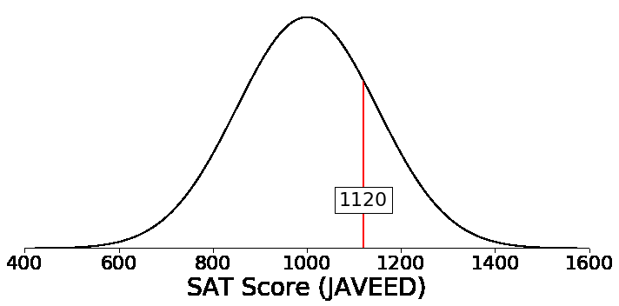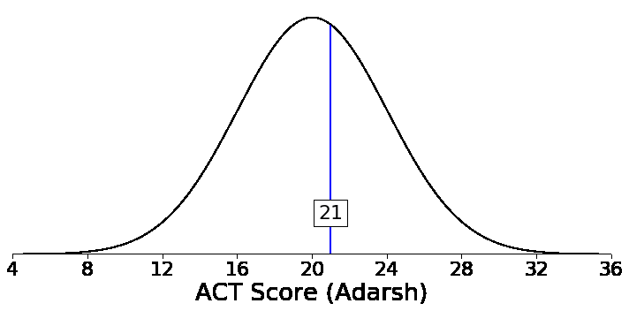

ACT score (adarsh) Z=(27-20)/4= 1.75 ,SAT score (javeed) Z=(11201000)/150=0.8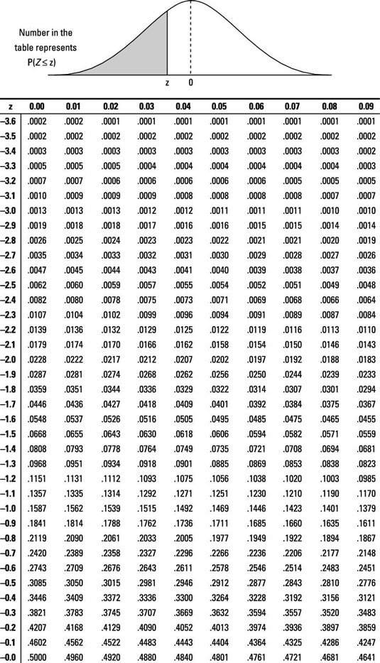

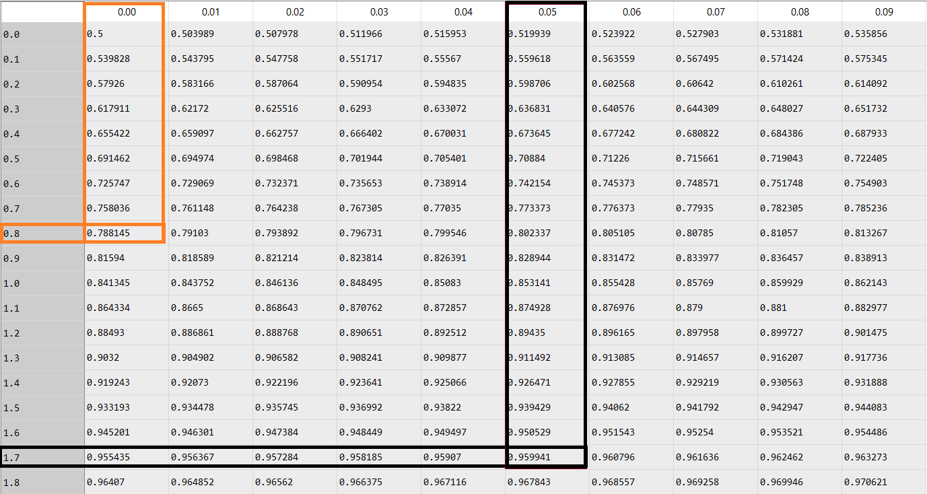

The probability of ACT score (adarsh) Z=1.75 ,SAT score (javeed) Z=0.8

**Adarsh (z-score = 1.75)**

To use the z-score table, start on the left side of the table go down to 1.7. At the top of the table, go to 0.05 (this corresponds to the value of 1.7 + .05 = 1.75). The value in the table is .8944 which is the probability. Roughly 89.44% of people scored worse than her on the ACT.

**Javeed (z-score = 0.8)**

To utilize the z-score table, start on the left side of the table go down to 0.8 and now at the top of the table, go to 0.00 (this corresponds to the value of 0.8 + .00 = .00). The value in the table is .8413 which is the probability. Roughly 84.13% of people scored worse than him on the SAT.

How the calculation will be done in z table is

With the help of the cumulative distribution function of a standard normal distribution with a mean of zero and standard deviation of one, we can calculate the table values.

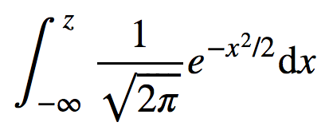

This is not an easy integral to calculate by hand so I am going to use Python to calculate it. The code below calculates the probability for Adarsh who had a z-score of 1.75 and Javeed who had a z-score of 0.8.

As the code below shows, these calculations can be done to create a z table.

